Analysis Report on Students’ Satisfaction Survey regarding Teaching-Learning Evaluation 2020-2021
Feedback from students during the academic year 2020-2021 were analysed based on a five-point measurement scale. 171 students responded through an online survey. Twenty parameters are analyzed.
The students involved in the survey were of the age group between 19 and 24 and most of the responses were from the age group 20 (35.7%) and 21 (37.4%). Out of 171 students about 75% were girls and most of the respondents were from Bachelor’s degree program. Most responses were from pupil pursuing their study in Arts subject (41.5%) followed by science (27.5%), commerce (16.4%) and professional degree (12.3%)

STUDENTS SATISFACTION SURVEY: RESPONSES
Questions | Responses
 | 1 | 2 | 3 | 4 | 5
How much of the syllabus was covered in the class? | 57.9% | 33.9% | 5.8% | 1.8% | 0.6%
How well did the teachers prepare for the class? | 43.9% | 54.4% | 1.2% | 0.6% | 0
How well were the teachers able to communicate | 75.4% | 18.1% | 5.3% | 0.6% | 0.6%
The teacher’s approach to teaching is | 54.4% | 33.3% | 11.7% | 0.6% | 0
The internal evaluation process by teachers are described as | 59.1% | 38.6% | 2.3% | 0 | 0
Was your assignment helping you in your subject learning? | 49.1% | 35.1% | 13.5% | 1.8% | 0.6%
The institute takes active interest in promoting extension activities, field visit opportunities for students? | 31.6% | 33.9% | 20.5% | 4.1% | 9.9%
The teaching and mentoring process in your institution facilitates you | 33.9% | 46.2% | 18.1% | 1.8% | 0
The institution provides various opportunities to learn and grow | 30.4% | 55% | 12.3% | 1.2% | 1.2%
Teachers inform you about the syllabus, course outcomes and program outcomes | 69.6% | 24.0% | 4.7% | 0 | 1.2%
Your class teacher does a necessary follow-up with you | 68.4% | 24.0% | 5.3% | 1.2% | 1.2%
The teachers illustrate the concepts through examples and applications | 62.0% | 29.2% | 8.2% | 0 | 1.2%
The teachers identify your strengths and encourage you with providing right level of works | 56.1% | 32.7% | 6.4% | 3.5% | 1.2%
The teachers are able to identify your weakness and help you to overcome them | 48.0% | 33.9% | 12.9% | 2.9% | 2.3%
The institution makes effort to engage students in evaluation and improvement of the learning process | 33.3% | 56.1% | 9.4% | 0.6% | 0.6%
The teachers use student centric methods such as experiential learning, participative and problem solving methodologies for enhancing learning experience | 45.0% | 45.0% | 6.4% | 2.9% | 0.6%
Teachers encourage you to participate in extracurricular activities | 48.5% | 39.2% | 7.6% | 4.1% | 0.6%
The institute make efforts to inculcate soft skills in you | 39.2% | 42.7% | 7.0% | 9.9% | 1.2%
What percentage of teachers use ICT tools, multimedia etc while teaching | 32.2% | 32.7% | 21.1% | 8.8% | 5.3%
The overall quality of teaching and learning process in your institution is very good | 43.3% | 46.8% | 7.6% | 1.2% | 1.2%

RESPONSE OF EACH QUESTION
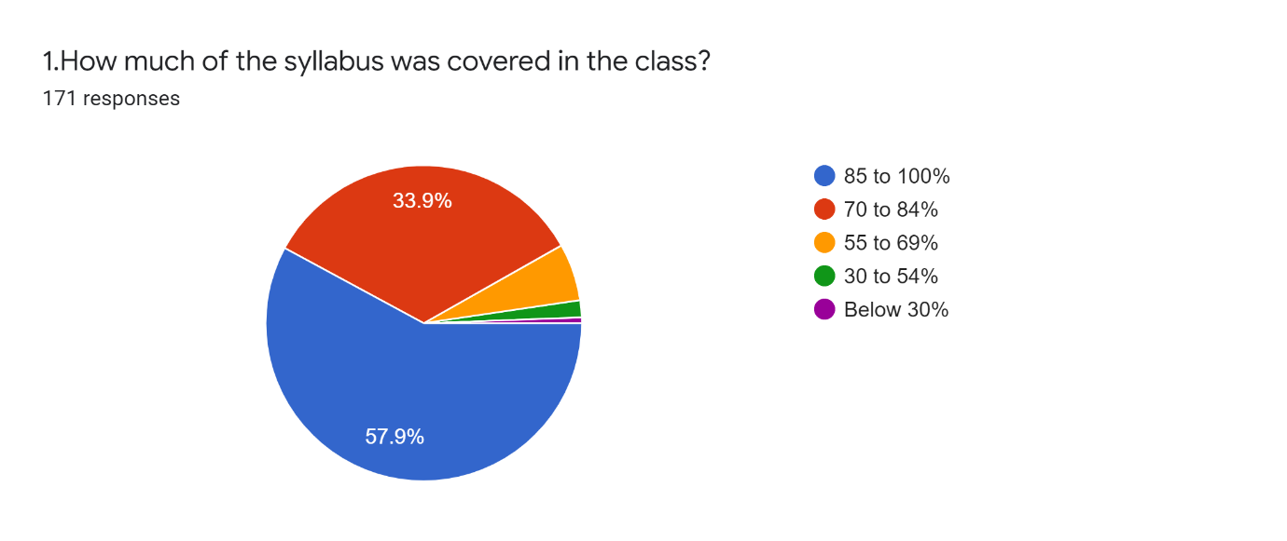
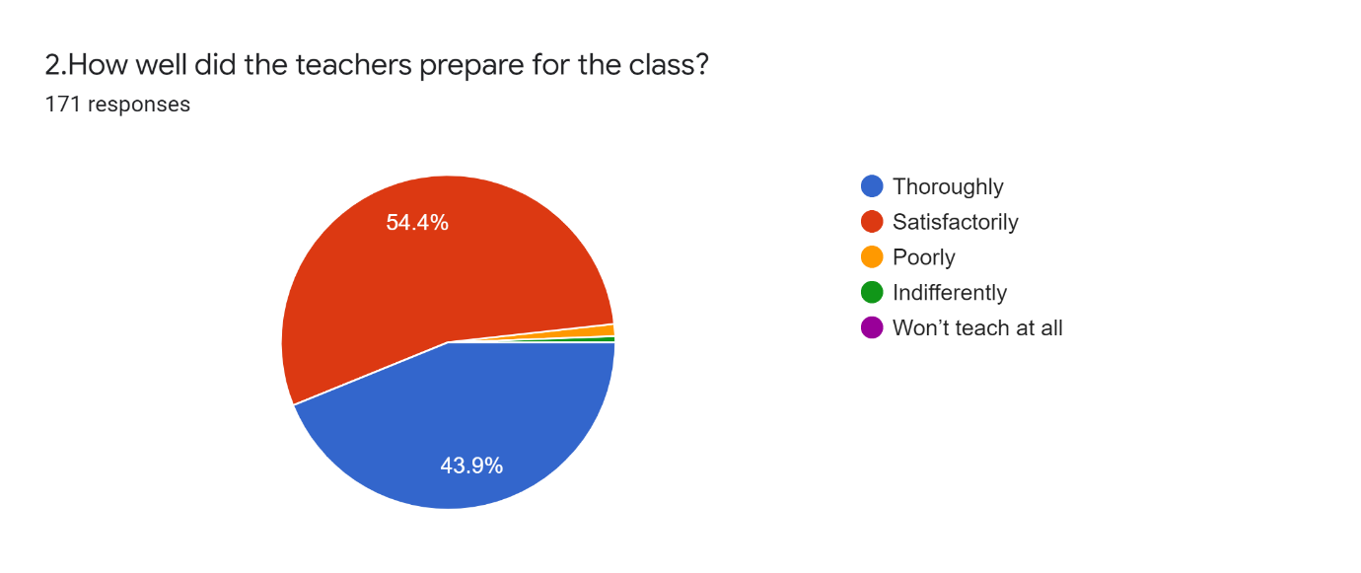
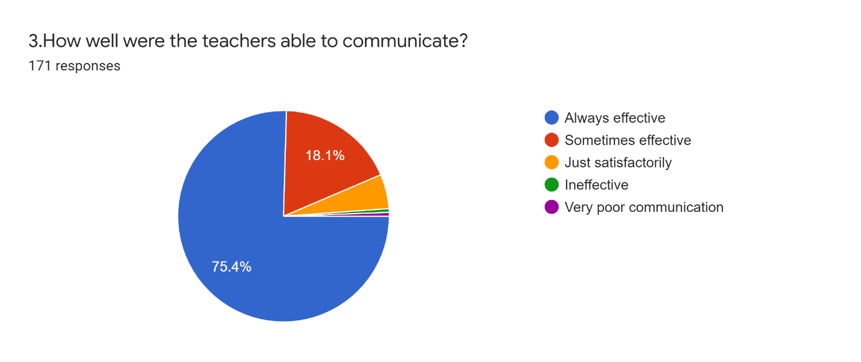
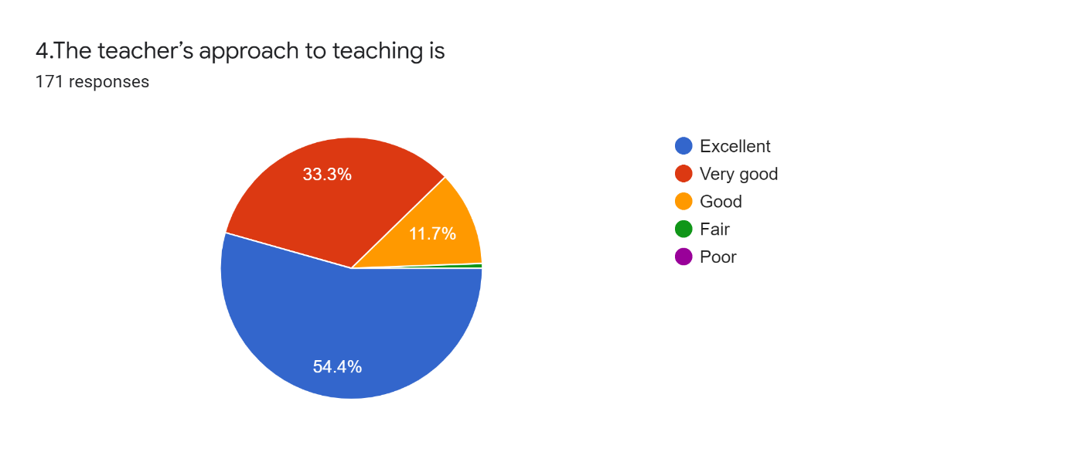
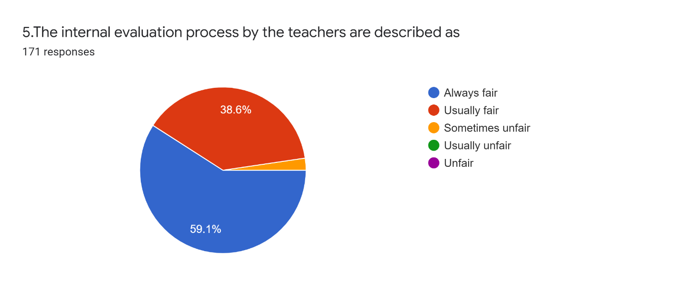
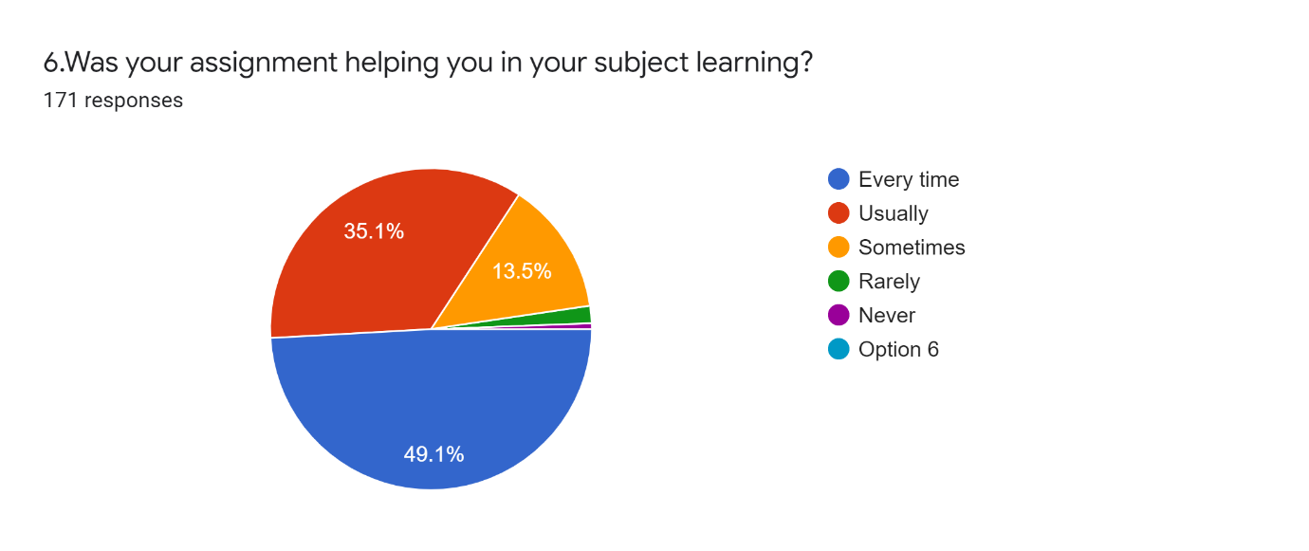
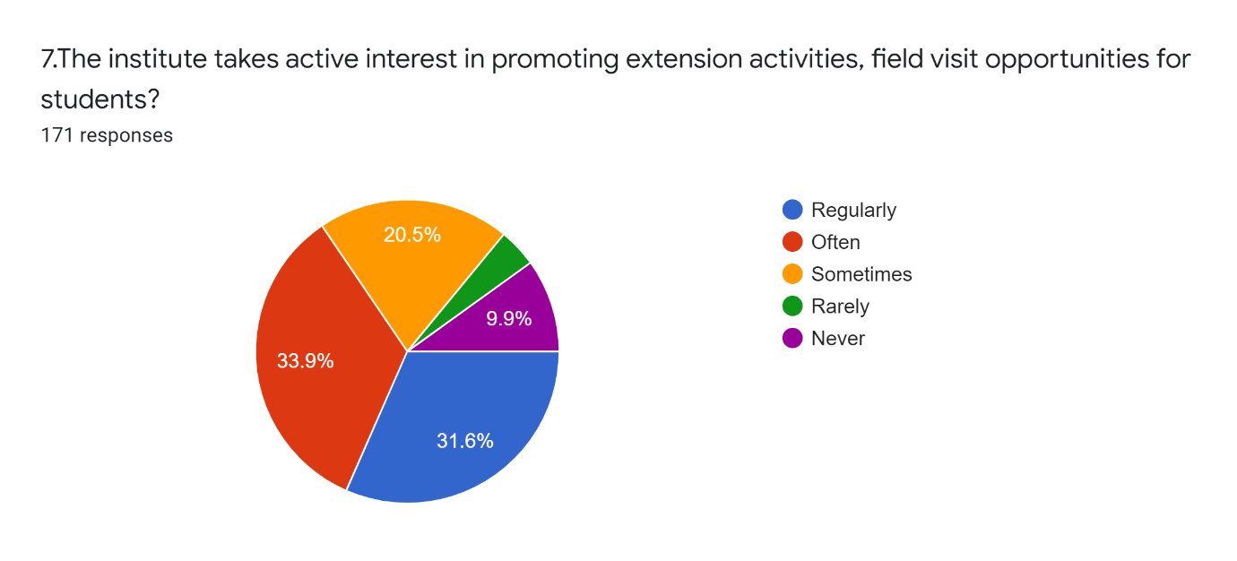
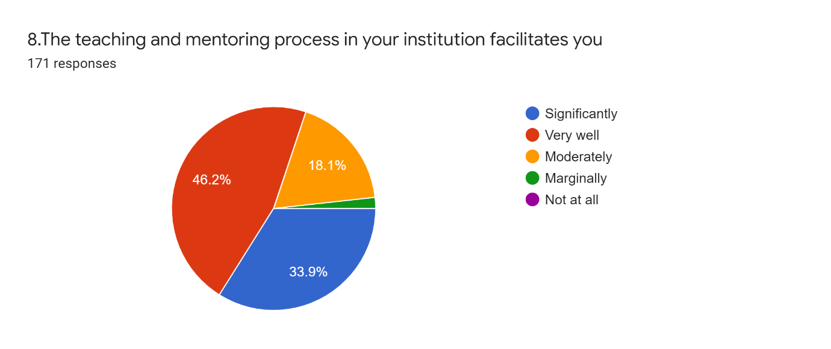
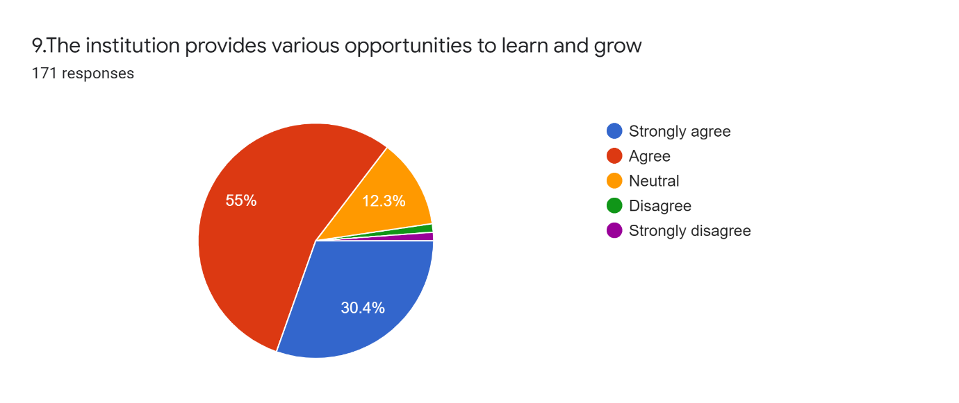
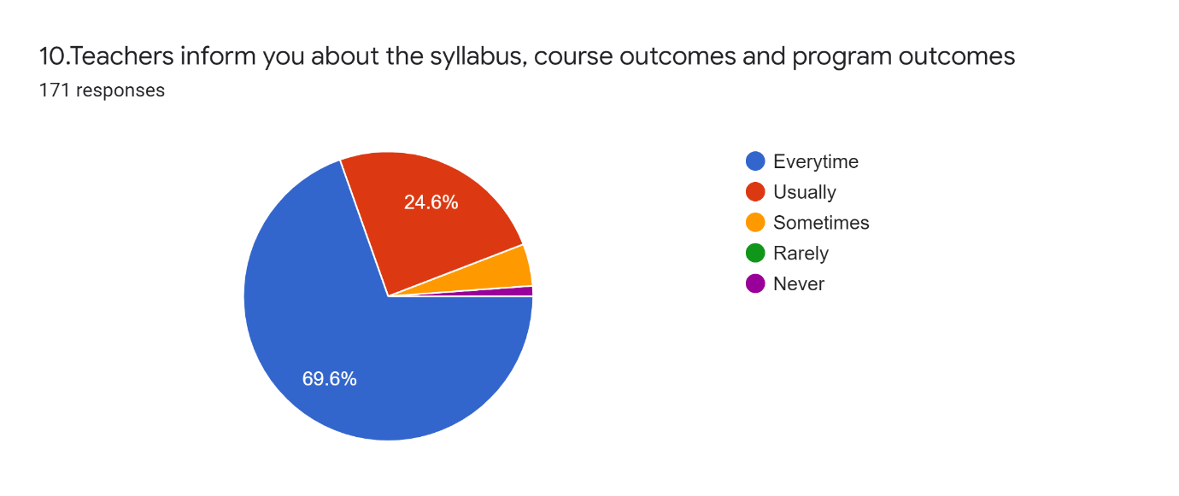
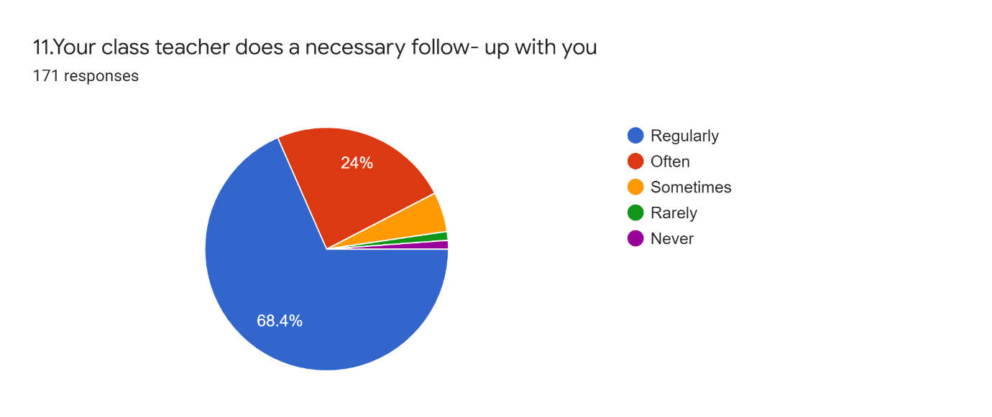
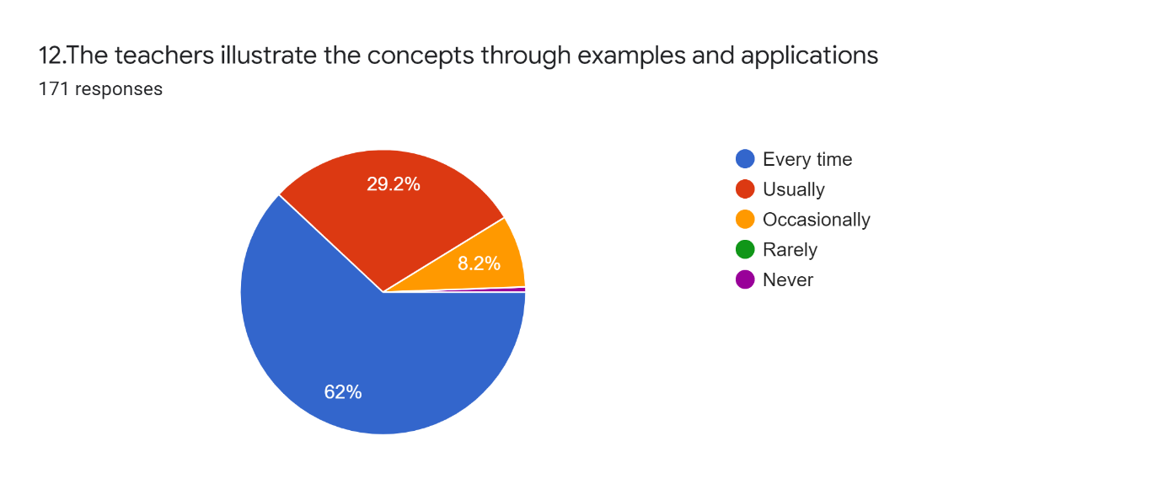
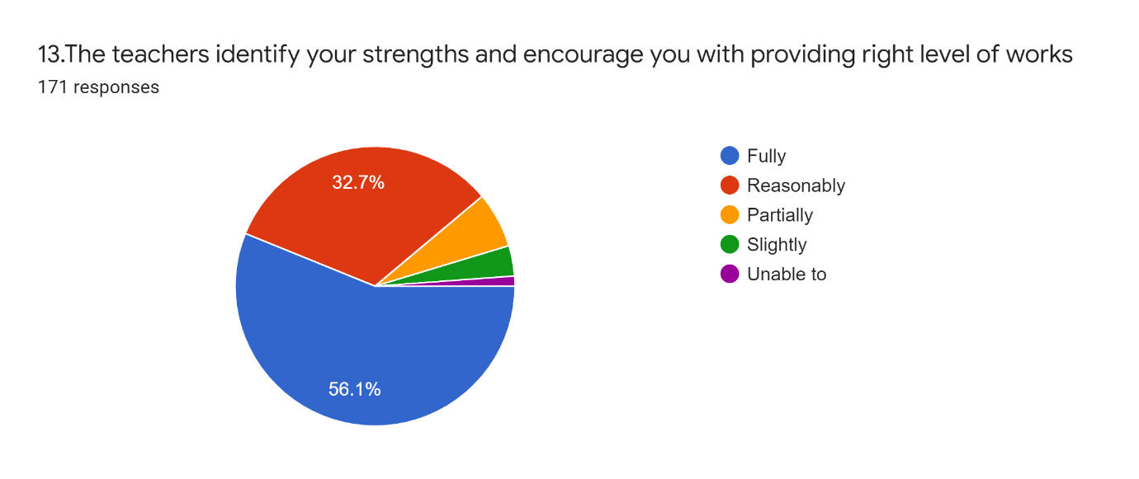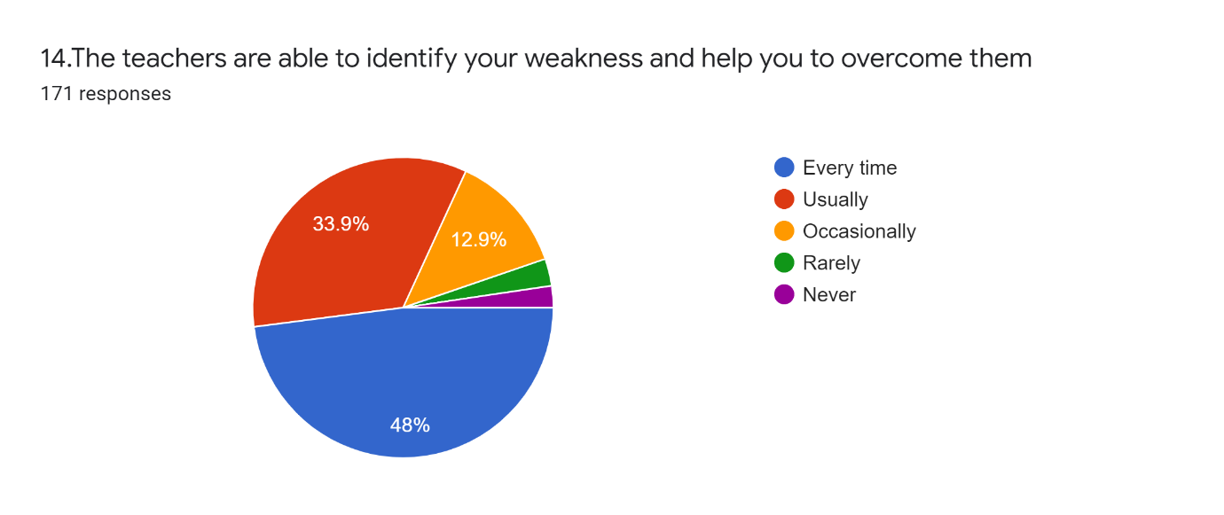
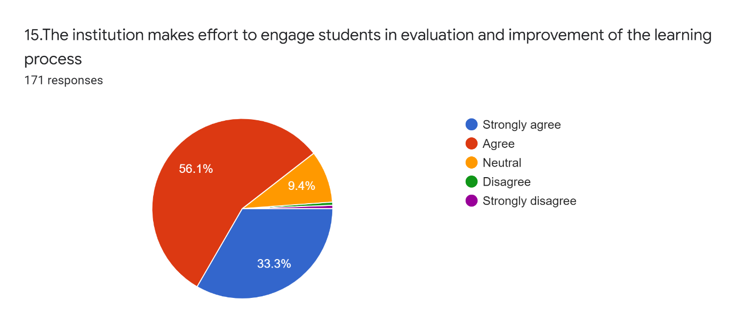
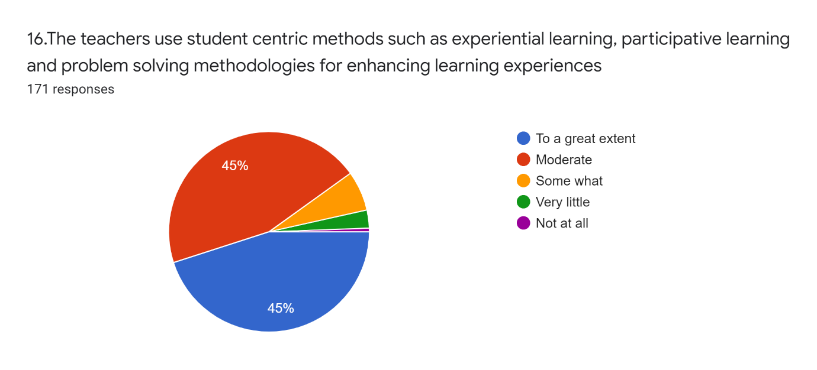
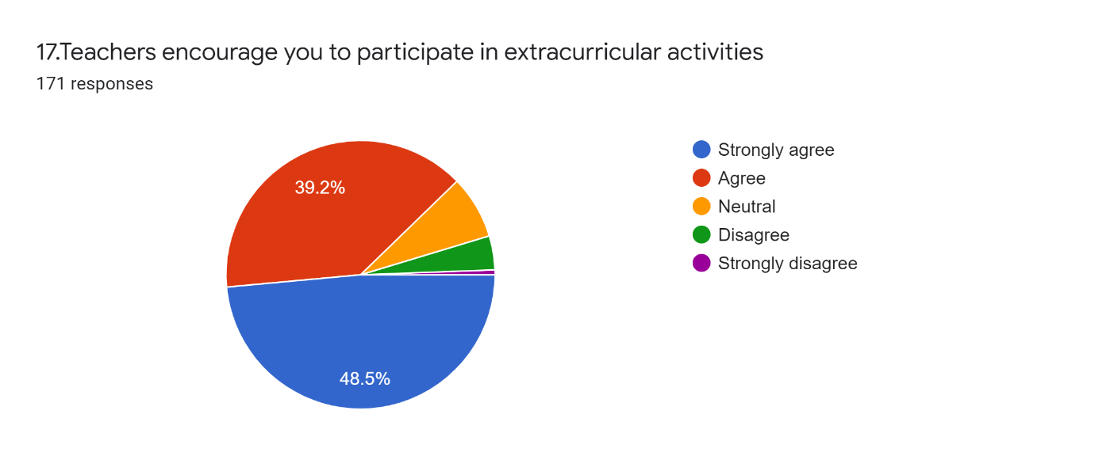

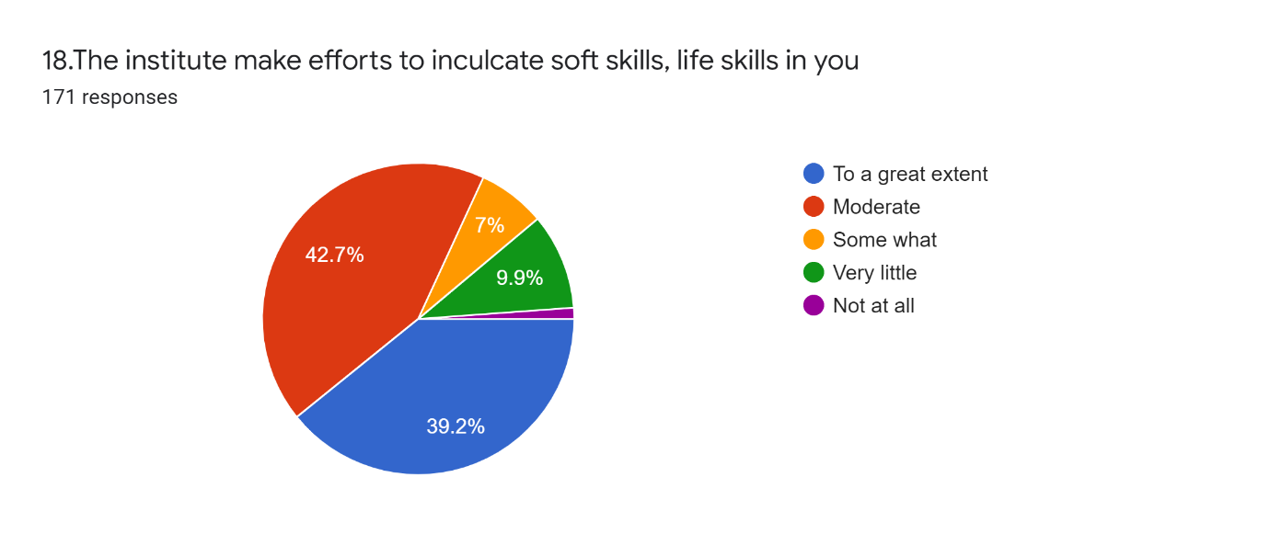
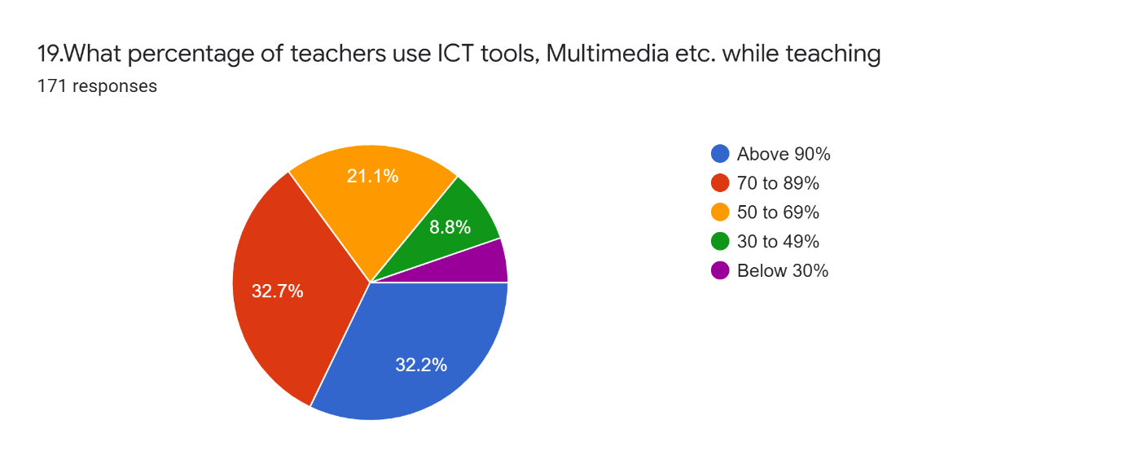
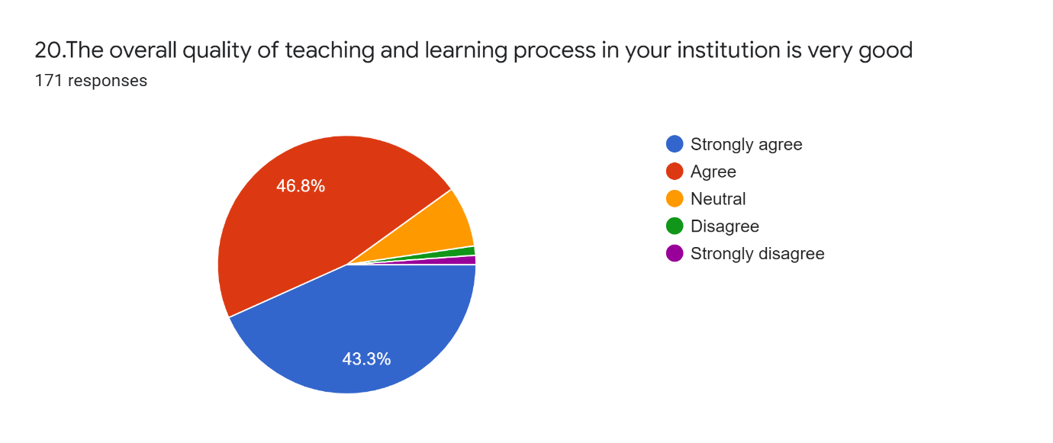

21. Give your observation/suggestions to improve the overall teaching-learning experience in your institution

There was a total of 171 responses. About 43 students were fully satisfied with the current teaching learning evaluation pursued in the institution and they recorded it as excellent or very good. About 19 students wanted a projector in the classroom, 6suggested for e-learning/ advanced learning technologies in classrooms. Some students suggested (5) interactive teaching methods. 5 students suggested the need of student centred as well as activity-based learning while 7 demanded more computers in the campus. About 8 students need teachers to be more friendly while 2 suggested that the teachers must be strict. Some demanded more books in the library on their subject (4) while others demanded (3) project work, study tours (1), skill development programs (2), outdoor classes (3), more seminars (1) and computer awareness classes (2). The suggestions like syllabus modification (2), good material facilities (1), experimental learning (3) and social learning (2). Some have an opinion about the conduct of examinations. Need of improvement in extra and co-curricular activities was mentioned by two of the students. Students were also aware about the infrastructure facility of the college and they suggested improvement (2). They opined that exam should be conducted at the right time (1) and conduct more test papers (1). They needed more career guidance classes and requested to guide them properly by discussing all the opportunities they will attain by completing their course. About 40 students gave no suggestion at all while 7 pupils did not respond to this question.
in addition to this the following suggestions were also made on general aspect of the college

The study ambience of the whole institution must be improved
Need proper waste management system
Need proper toilet facilities
Inadequate availability of certain resources.
Ensure good material facilities
Institution as such is maintaining average standard but departments performance is remarkable
Adopt new methods for overall improvement of the college

